**ARYAN SCHOOL OF ENGINEERINH AND MANAGEMENT**

**(Affiliated to Purbanchal University)**

**Mid Baneshor, Kathmandu**



A PROJECT PROPOSAL ON

**“ WORKSHOP LISTING SYSTEM ”**

Submitted by

Mahesh Kc

Pramod Singh

Submitted to

(Department of Information Technology

Aryan School of Engineering and Management

Mid Baneshor, Kathmandu)

Submitted date:

# ABSTRACT

At present, people do not only consider their vehicle as a luxury but also a necessity. They use their vehicles to go from place to place to run their errands and tasks. A vehicle requires maintenance and repair because it is made up of important components and machines to keep it working. Vehicle repair and maintenance aid vehicle owners in avoiding unexpected vehicle breakdowns. Early detection of vehicle faults is critical before they become major concerns.

The workshop listing system is the project which provide services of providing information of workshop and its services at anywhere anytime. Most of the vehicle owner have been facing the breakdown of their vehicle on middle of the way. So to address their problem. A user will be provided name, address, contact number and its services of workshop. Also they will be given details about available services and their fare.

# ACKNOWLEDGEMENT

First, we would like to express our heartfelt thanks ‘for this golden opportunity’, which they rendered to us and give the physical strength and pleasant mind to complete this proposal work. Our appreciation goes all to our friends for the immense support they gave to us be it moral, physical or financial. We are also grateful to our project guide Mr. Saugat Timsina, Mrs. Anjali Kesari, Mr. Karna Bahadur Shrestha and Er. Nisha Karki for the guidance, inspiration and constructive suggestion that were very helpful for us in the preparation of this proposal.

# TABLE OF CONTENT

Contents

ABSTRACT ii

ACKNOWLEDGEMENT iii

TABLE OF CONTENT iv

LIST OF FIGURE vi

CHAPTER 1: INTRODUCTION 1

1.1 Background 1

1.2 Problem Statement 1

1.3 Objectives 2

1.4 Applications 3

1.5 Project Features 3

1.6 Feasibility Analysis 3

1.6.1 Economic Feasibility 3

1.6.2 Technical Feasibility 4

1.6.3 Operational Feasibility 4

1.7 System Requirement 4

1.7.1 Software Requirement 4

1.7.2 Hardware Requirement 4

CHAPTER 2: LITERATURE REVIEW 6

CHAPTER 3: METHODOLOGY 7

Algorithm 7

3.1 System block diagram: 7

Flowchart: 8

CHAPTER 4: RESULT AND DISSION 9

4.1 Expected Output 9

4.2 Project schedule 9

CHAPTER 5: CONCLUSION 10

REFERENCES 11

# LIST OF FIGURE

Figure i: System Block Diagram 7

Figure ii: Flowchart 8

Figure iii: Work Schedule 9

# CHAPTER 1: INTRODUCTION

## 1.1 Background

At present, transportation technology is growing fast. However, many car owners and driver have less knowledge on detecting and diagnosis faults in their cars. Automobile problem or fault detection is a complicated process which demands high level of knowledge and skill, which is not possible for every owners or drivers to gain. As a result, there is a need for frequent maintenance as well as time to repair if necessary.

Workshop listing system is designed to provide the information of workshops nearby the user with their available services. The automobile listing system can be defined as an online system which helps to find out workshops and available services with their fare to the user.

## 1.2 Problem Statement

At present, people do not only consider their vehicle as a luxury but also a necessity. They use their vehicles to go from place to place to run their errands and tasks. A vehicle requires maintenance and repair because it is made up of important components and machines to keep it working. Vehicle repair and maintenance aid vehicle owners in avoiding unexpected vehicle breakdowns because they don’t have enough time. The following problems have been mentioned by the users.

* Lots of owner have to face a problem of vehicle breakdown in the middle of their destination.
* Not all time everyone have contact in workshops and they have to face lots of losses if they face vehicle breakdown anywhere.
* Don’t know about services and its fare.

## 1.3 Objectives

The main objectives of our project are:

1. To give the knowledge to people about the online workshop listing system.
2. To make people who suffers breakdown of their vehicle in middle of the way, easier and convenient to contact in workshop nearby.
3. To give the information about workshops services and its fare.

## 1.4 Applications

Our project is made to educate the automobile owners and drivers about online workshop listing system. This project is applicable in every capable part of Nepal.

## 1.5 Project Features

Main features of this project include:

* File: Use of file handling to take the user details like name and contact number.

## 1.6 Feasibility Analysis

### 1.6.1 Economic Feasibility

This feasibility looks at the costs incurred in operating the system versus the revenue and accumulated returns. Automobile listing system is economically feasible in the sense that; it is cheaper to acquire, it saves on the time and engagement to go to search nearby workshop and services since it operates automatically. Our system provides quick information to the workshop and also user can contact in workshop quickly which may save their time and strength.

### 1.6.2 Technical Feasibility

The system is technically feasible in a number of ways. It was developed using a number of readily available in C programming. Coding was done using Object Oriented Programming Language in C. All the required hardware and software are readily available in the market.

### 1.6.3 Operational Feasibility

Operational feasibility evaluates whether a system is relevant to operate in a particular environment. Automobile listing system contains a number of features making it operationally feasible. Available workshops information are generated by a function that retrieves relevant information from the program and present to a user in simple formats. The system is easy to use hence it enables any user with minimal computer skills to use it.

## 1.7 System Requirement

### 1.7.1 Software Requirement

For the program to be run, the set of following computer software must be prepared with following specifications:

* Operating system: Windows 7/10/13/16
* Database Server: MS Access

### 1.7.2 Hardware Requirement

For the program to be run, the computer hardware must be prepared with the following specifications:

* 2GB RAM or More
* Hard disc 8 GB

# CHAPTER 2: LITERATURE REVIEW

The automobile listing system is directly assist to user and consumers. Where they can easily manipulate their automobile (vehicle) facing or occur problems in their middle of their way. This system will make easier for the users to get all the information about services of nearby workshops after using our application in their device. This automobile workshop system will show all the services details provided by different automobile workshops, nearby them in which will have good time saving and solving the problem by using our system.

A staged modelling approach was proposed following this review. Potential sources of vehicle repair and maintenance data across six vehicle categories were investigated with respect to the likelihood of obtaining data appropriate to the proposed modelling approaches. Details of the proposed research plan are outlined, giving time scales for the phases of the work. The execution and preliminary analysis of a survey of vehicle fleet operators and a centralized fleet-asset management agency are reported. (California Transit Association, 1998)

1

Automobile maintenance and repair are performed by human experts (auto mechanic) and expert system. An expert system can be defined as an intelligent computer program that uses knowledge and inference procedure to solve problems that are difficult enough to require significant human expertise for their solutions (Giarratano and Riley, 2004).

Chakraborty (2010) defined it as an interactive computer-based decision tool that uses

both fact and heuristics to solve difficult decision-making problem base on knowledge acquire from an expert. An expert system employs human knowledge captured in a computer to solve problem that ordinarily require human expertise (Hope and Wild,1994). In an expert system, there is always transference of knowledge from human expert to a computer. This is normally represented by facts and rules in the systems. Advice and proof for any problem in a specific domain for the users upon their request can be provided by the system (Ahmad and Al-Taani, 2005).

# CHAPTER 3: METHODOLOGY

## Algorithm

The program has following options to enter:

* Add Workshop
* Available Workshop
* Update Workshop
* Delete Workshop
* Exit

### 3.1 System block diagram:

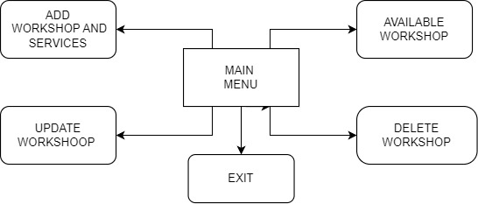

Figure i: System Block Diagram

## Flowchart:

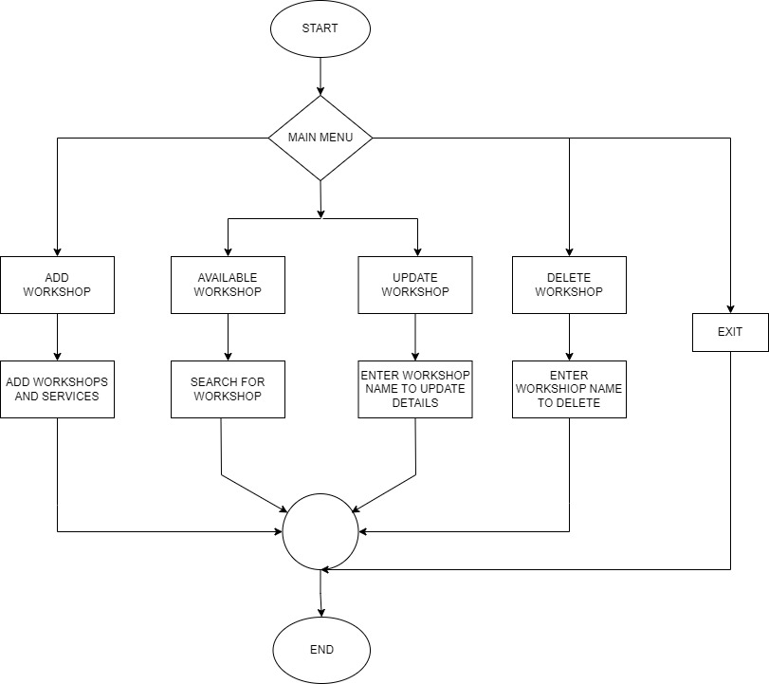

Figure ii: Flowchart

# CHAPTER 4: RESULT AND DISCUSSION

### 4.1 Expected Output

The following output can be expect from this location system:

1. Add Workshop
2. Available Workshop
3. Update Workshop
4. Delete Workshop
5. Exit

### 4.2 Project schedule

A chart in which a series of horizontal lines shows the amount of worked done or production completed in certain period in relation to the amount planned for periods.

### 

Figure iii: Work Schedule

# CHAPTER 5: CONCLUSION

This project was conducted to assess the current problems regarding vehicle breakdown in the middle of the way. The study reveals that vehicle owner still use the manual method which is ineffective. With this, we developed an automated vehicle workshop listing system and presented it to the respondents and intended end-users. The result of the study showed that the developed system met the predefined needs and requirements of the target users. The respondents rated the system satisfactorily in terms of the system’s acceptance, efficacy, quality, productivity, and dependability among users.

Hence, It can be concluded that the developed system is an effective platform to automate vehicle repair and maintenance management. The system will automate operations such as providing information of different workshop and its services.

* The main motive of our project was to help to give information of workshop services regarding vehicle.
* The developed system met the predefined needs and requirements of the target users.
* This system may be the effective platform to automate workshop listing management.
* It will ease up and simplify the user of vehicle to repair and maintenance.

# REFERENCES

(California Transit Association, 1998).

Giarratano, J., & Riley,G., (2004). Expert Systems: Principle and Programming, Fourth Edition.

Chakraborty, R.C. (2010). Expert System Artificial Intillegence. Retrieved from

http//www.myreaders.info/07_ Expert_System.pdf.

Hope, B.G., & Wild, R.H. (1994). An Expert Support System for Service Quality

Improvement: In Proceedings of the Twenty-Seventh Annual Hawaii International

Conference on System Science.

Ahmad, T., & Al-Taani, A.T. (2005). An Expert System for Car Failure Diagnosis.

World Academy of Science, Engineering and Technology, 1(12), 457-560.